# Organizational Behavior: Change

Student’s Name Institution

Course Name Professor’s Name Date

# Organizational Behavior: Change

Change is an important aspect of organizational behavior as it influences the business performance amid dynamic times. However, organizations that are retrogressive entertain

humorous remarks, such as “as soon as we solve one problem, another one appears. So let’s keep this problem going for as long as we can” (Glasbergen, n.d.). The remarks are a comic strip that demonstrates the unwillingness of employees to adjust to changes through creative thought

processes that yield solutions to problems. Organizational behavior is a critical influential factor of change. Firms use organizational behavior screenings to understand the employees’ attitude and performance that depict the direction a company will take. The company’s cultures, structures, and policies are responsible for the organization’s behavior that is a reflection of the employees’ performance and willingness to change. The comic strip that is further demonstrated in figure 1 below elaborates the absence of organizational behavior that supports changes.

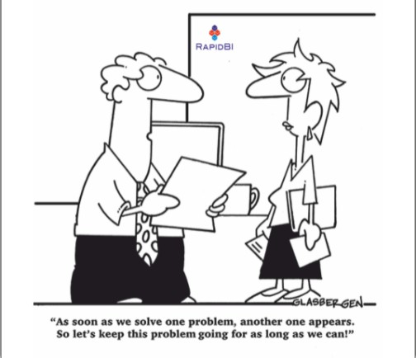

Figure 1: Comic Strip (Glasbergen, n.d.)

The comic strip demonstrates employees’ resistance to change due to fear of the unknown consequences (Glasbergen (n.d.) shows an employee resisting change since they anticipate that solving one problem, which would have been a significant milestone for the

organization, will generate another undesired consequence. The employees’ fears are justifiable as Furxhi (2021) argues that every change initiated in an organization results in a new situation that is unknown to all parties. This reason explains the humorous strip, as individuals resist

change to avoid the uncertain effects and dwell in the known that is a satisfactory phase. Such

resistance can have adverse effects on the organization, resulting in low productivity or delayed processes that generate losses for the entity. Therefore, the comic strip is a demonstration of the employees’ fear for the unknown and preference to dwell with what is certain to avoid undesired consequences as part of the organization’s behavior impacts on change.

Various factors influence the employees’ behavior and their resistance to change, resulting in remarks such as the ones displayed in the comic. Furxhi (2021) found that individual interest, low tolerance to change, and change misunderstandings are the primary factors that

influence an individual’s resistance to change. Individual interest is a product of a person’s perception of change and factors such as past experiences on change management can result in either a negative or positive attitude toward proposed change. An additional reason that could explain why the employee said that they should avoid solving the current problem is due to lack of confidence and fear of failure, which affects a person’s ability to respond to change. Thus, the factors that contribute to resistance to change include an individual's interests and perceptions,

low tolerance due to lack of confidence or misunderstandings that arise from fear of failure.

Organizations have to adapt to changes to keep up with the competitive business

environments but it is unfortunate that employees resist the dynamism. The comic is a clear indication that employees can prefer to settle for a known problem and avoid finding a solution to prevent a new problem from developing, which can result in undesired effects. Such thoughts are retrogressive to both the employee and the organization and can have significant cost in the long run. Distrust, lack of confidence, and fear of failure are some of the primary factors that inhibit change in an organization. Therefore, entities should address the issues to improve organizational behavior and positively impact changes.

# References

Furxhi, G. (2021). Employee’s resistance and organizational change factors. European Journal of Business and Management Research, 6(2), 30-32. https://doi.org/10.24018/ejbmr.2021.6.2.759

Glasbergen, R. (n.d.). *RapidBI Daily Cartoon #74: A look at the lighter side of work.* Rapidbi. https://in.pinterest.com/pin/rapidbi-cartoons--135037688801978500/